Suture Information
Pack

What is a suture?

A suture is a strand of material used to tie (ligate) blood vessels and to sew (approximate) tissues together.

Suture size and types
There are many different types of suture, the two most important properties are...
Absorbable Vs Non-Absorbable
and
Braided Vs Non-Braided

Absorbable Suture
Absorbable suture breaks down over time in the body. Examples of absorbable suture include Monocryl, Vicryl, Chromic, and PDS. The amount of time it takes a suture to break down in the body depends on a few factors such as suture type, size and the location it is placed.

Non-Absorbable Suture
Nylon (Ethilon), Gortex, Silk, Fiberwire, Ethibond, Prolene and Steel are all example of non absorbable suture. When used on the skin, these sutures will be removed however when used in the body they will be retained inside the tissue.

Braided or Non-Braided Suture
Braided suture have a number of strands woven together like a string. Examples of braided suture are; Silk, Vicryl and Ethibond. Non-Braided or Monofilament Sutures have a single strand such as Monocryl, PDS,and Ethilon Nylon.
Often times it will be surgeon preference when choosing a braided or non-braided suture. Vicryl and Monocryl are both commonly used for suturing of the skin, they are both absorbable however vicryl is braided and monocryl is non-braided.
It is thought that non-braided sutures cause less reactivity in the body and are not as prone to becoming infected because they lack the grooves and rough surface for things to adhere. However non-braided sutures can have a greater tendency to loosen at the surgical knot with the lack of grip.

Suture sizes are defined by the United States Pharmacopeia (U.S.P.). Sutures were originally manufactured ranging in size from #1 to #6, with #1 being the smallest. A #4 suture would be roughly the diameter of a tennis racquet string. The manufacturing techniques, derived at the beginning from the production of musical strings, did not allow thinner diameters. As the procedures improved, #0 was added to the suture diameters, and later, thinner and thinner threads were manufactured, which were identified as #00 (#2-0 or #2/0) to #000000 (#6-0 or #6/0).
Modern sutures range from #5 (heavy braided suture for orthopedics) to #11-0 (fine monofilament suture for ophthalmics).
Smallest
10-0, 9-0, 8-0 Typically used in the most delicate surgeries. Common in Ophthalmic surgery and for repairing small damaged nerves often due to lacerations in the hand.
7-0 Used for repairing small vessels and arteries or for delicate facial plastic surgery.
6-0 Common for use in vascular graft sewing such a carotid endarterectomy.
5-0 & 4-0 Used for larger vessel repair such as an Abdominal Aortic Aneurysm or skin closure.
3-0 & 2-0 Skin closure when there is a lot of tension on the tissue, closure of muscle layers or repair of bowel in general surgery.
0 & 1 For closing of the fascia layer in abdominal surgery, the joint capsule in knee and hip surgery or deep layers in back surgery.
2 - 5 For repair of tendons or other high tension structures in large orthopaedic surgeries.
Largest

Suture Needles
Carefully selecting a surgical suture needle is a critical component in achieving excellent wound closure outcomes. The ideal surgical needle should be:
Sharp enough to penetrate and carry suture through tissue with minimal resistance
Slim as possible without compromising strength
Rigid to resist bending, yet flexible enough to bend before breaking
Sterile and corrosion resistant to prevent introduction of micro-organism’s or foreign bodies into the wound.

Types of Suture Needle points and body shapes
Sutures can either be eyed where they need to be threaded with suture or eyeless where the suture is braided into the needle during the manufacturing process. These eyeless sutures can also be known as ‘atraumatic’ sutures as they cause less trauma to the tissues than an eyed suture would due to less drag at the thread attachment site.
Needle Curvature
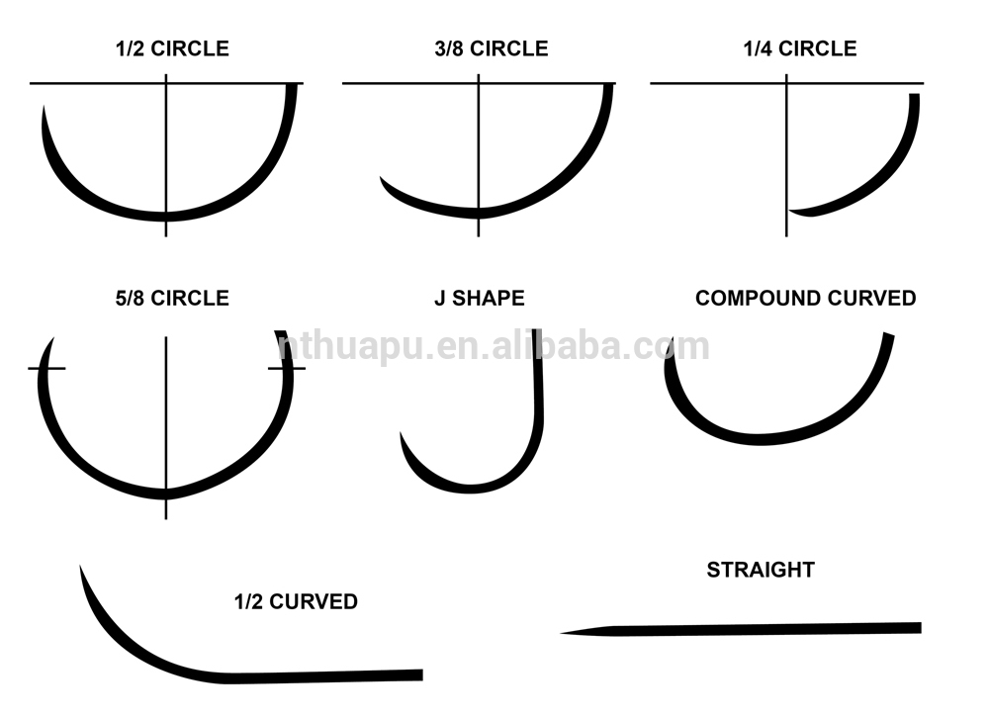
Straight needles – used where tissue is easily accessible and designed to be used by hand. Straight needles are most used for skin closure or microsurgical procedures like nerve and vessel repair.

Half Curved Needle (ski) – used during laparoscopic surgery as the needle design allows for it to pass through narrow cannulas.

¼ circle – typically used in Ophthalmic and microsurgical procedures.

½ circle – easier to use in confined locations. Used for muscle, eye, skin and peritoneum.

3/8 circle – most commonly used. Can be easily manipulated and often used for relatively large and superficial wounds. Impossible to use in deep cavities due to the large arc of manipulation needed.

5/8 circle – Ideal for deep confined holes such as cardiovascular, oral and pelvis.

J shape – to access deep tissues in a confined space. For example, to close the sheath in a laparoscopic port site.

Compound curve – anterior segment of the eye.

Needle Points
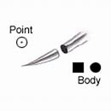
Taper Point Needle
Needle body is round and tapers smoothly to a point. Used primarily on soft easily penetrated tissue such as the peritoneum. Passes through tissue by stretching rather than cutting. If you are ever unsure about whether to choose taper point or cutting needle chose taper point for everything but skin sutures.

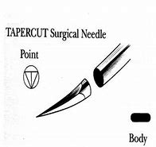
Tapercut Needle
Sharp reverse cutting tip at the point with a narrow bodied round tapered needle. All three edges of the tip are sharpened to provide uniform cutting action. Used in tough hard to penetrate tissues.

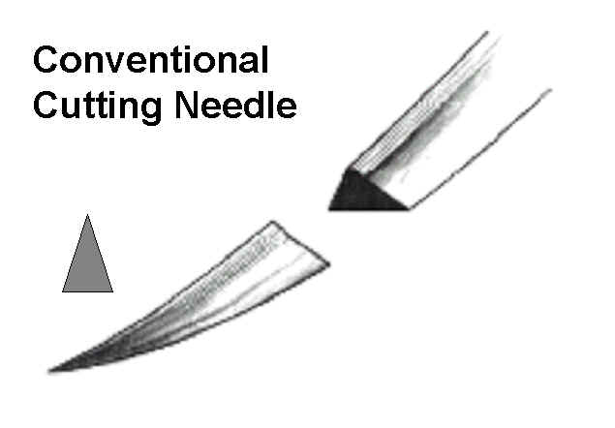

Conventional Cutting Needle
Two opposing cutting edges (triangular shape) with a third sharpened cutting edge on the inside curvature of the needle. Sharpened to cut through tough, difficult to penetrate tissue. Ideal for skin sutures.

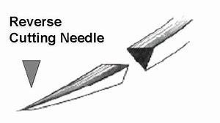

Reverse Cutting Needle
Same as conventional cutting needle but with the third cutting edge on the outer curvature of the needle. Used to cut through tough difficult to penetrate tissues such as fascia, oral mucosa, tendon sheath and skin.

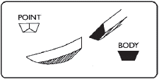

Spatula Needle
Designed for ophthalmic procedures. They permit the needle to separate or split through the thin layers of scleral or corneal tissue and travel within the plane between them with virtually no resistance. The needle is flat on both the top and bottom.

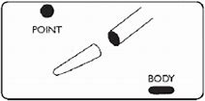

Blunt Point Needle
Taper needle with round blunt point does not cut through tissue but dissects it instead.. Used in blunt dissection and the suturing of friable tissues such as liver and kidney.

Needle Cut symbols

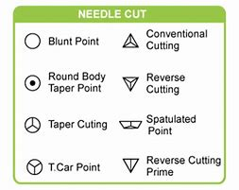

Coated VICRYL (polyglactin 910) Suture

Coated VICRYL Suture is a synthetic absorbable sterile surgical suture composed of a copolymer made from 90% glycolide and 10% L-lactide.
Coated VICRYL sutures are intended for use in general soft tissue approximation and/or ligation, including use in ophthalmic surgery, peripheral nerve anastomosis and microsurgery for vessels less than 2 mm diameter.
This suture, being absorbable, should not be used where extended approximation of tissue under stress is required.

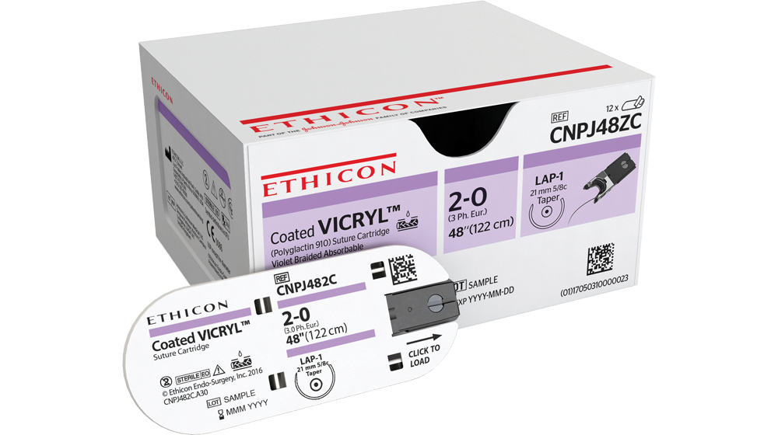

MONOCRYL (poliglecaprone 25) Suture
MONOCRYL Sutures is a monofilament synthetic absorbable surgical suture prepared from a copolymer of glycolide and epsilon-caprolactone.
MONOCRYL Sutures are indicated for use in general soft tissue approximation and/or ligation where an absorbable material is indicated.
These sutures (dyed and undyed), being absorbable, should not be used where extended approximation of tissues under stress is required. Monocryl UNDYED must not be used for abdominal closure or to close fascial tissue.

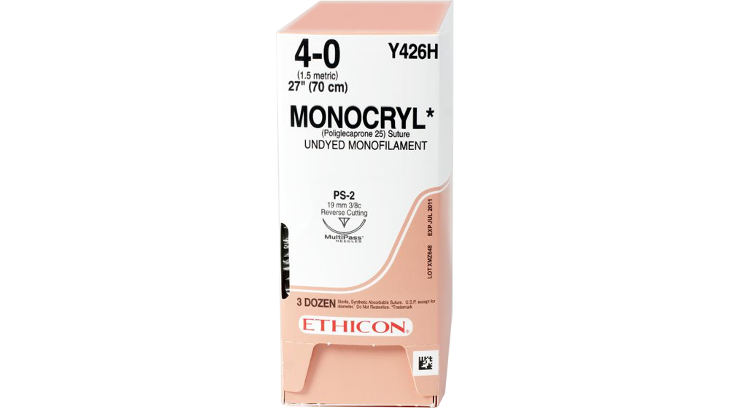

PDS II (polydioxanone) Suture
PDS II Suture is a sterile synthetic absorbable monofilament suture made from the polyester (p-dioxanone.)
PDS II sutures are intended for use in general soft tissue approximation, including use in paediatric cardiovascular tissue, in microsurgery and in ophthalmic surgery. These sutures are particularly useful where the combination of an absorbable suture and extended wound support (up to six weeks) is desirable.
These sutures, being absorbable, should not be used where prolonged (beyond 6 weeks) approximation of tissues under stress is required or in conjunction with prosthetic devices, for example, heart valves or synthetic grafts.

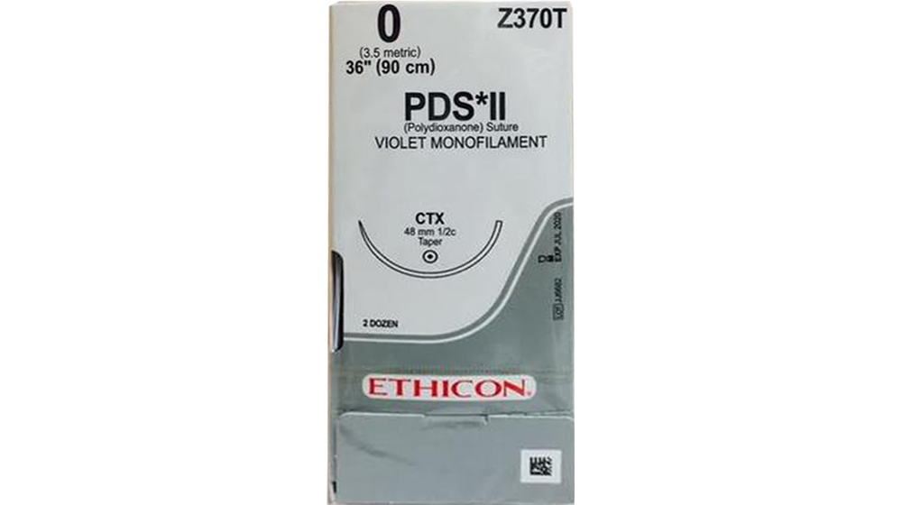

VICRYL RAPIDE (polyglactin 910) Suture
Coated VICRYL RAPIDE Suture is a synthetic absorbable sterile surgical suture composed of a copolymer made from 90% glycolide and 10% L-lactide.
Coated VICRYL RAPIDE Suture is indicated for use in soft tissue approximation where only short term wound support is required and where the rapid absorption of the suture would be beneficial. Due to its absorption profile VICRYL RAPIDE is useful for skin closure, particularly in paediatric surgery, episiotomies, circumcision and closure of oral mucosa. VICRYL RAPIDE is also successfully used in ophthalmic surgery for conjunctival sutures.
Due to the rapid loss of tensile strength, VICRYL RAPIDE should not be used where extended approximation of tissues under stress is required or where wound support or ligation beyond 7 days is required.

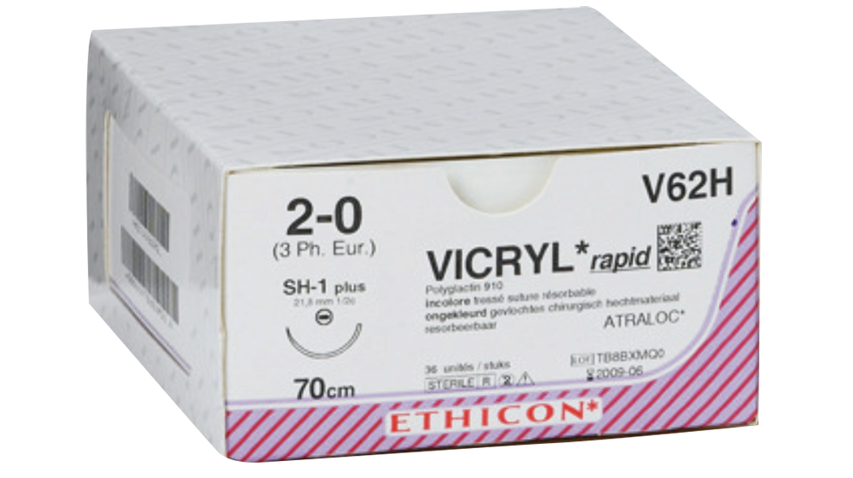

ETHIBOND EXCEL Polyester Suture
ETHIBOND EXCEL Polyster Suture is a nonabsorbable, braided, sterile, surgical suture composed of Poly (ethylene terephthalate). It is prepared from fibers of high molecular weight, long-chain, linear polyesters having recurrent aromatic rings as an integral component.
ETHIBOND EXCEL Suture is braided for optimal handling properties, and dyed green for enhanced visibility.
ETHIBOND EXCEL Suture is indicated for use in general soft tissue approximation and/or ligation, including use in cardiovascular, ophthalmic and neurological procedures.

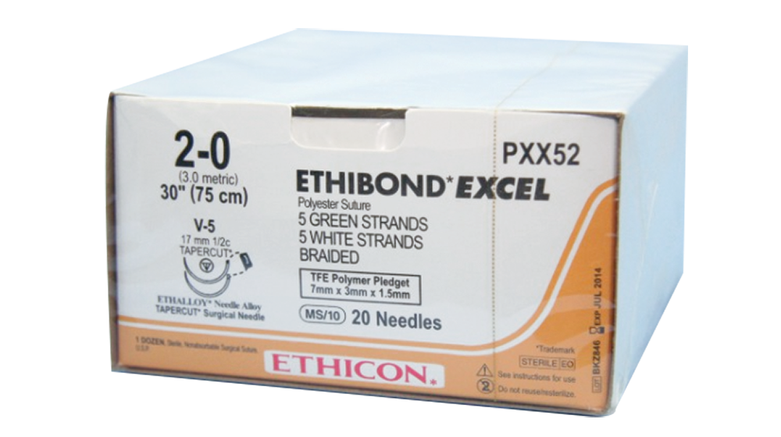

ETHILON Nylon Suture
ETHILON Suture is nonabsorbable, sterile surgical monofilament suture composed of the long-chain aliphatic polymers Nylon 6 and Nylon 6,6.
ETHILON Suture is dyed black to enhance visibility in tissue. The suture is also available undyed (clear.)
ETHILON Suture is indicated for use in general soft tissue approximation and/or ligation, including use in cardiovascular, ophthalmic, and neurological procedures.

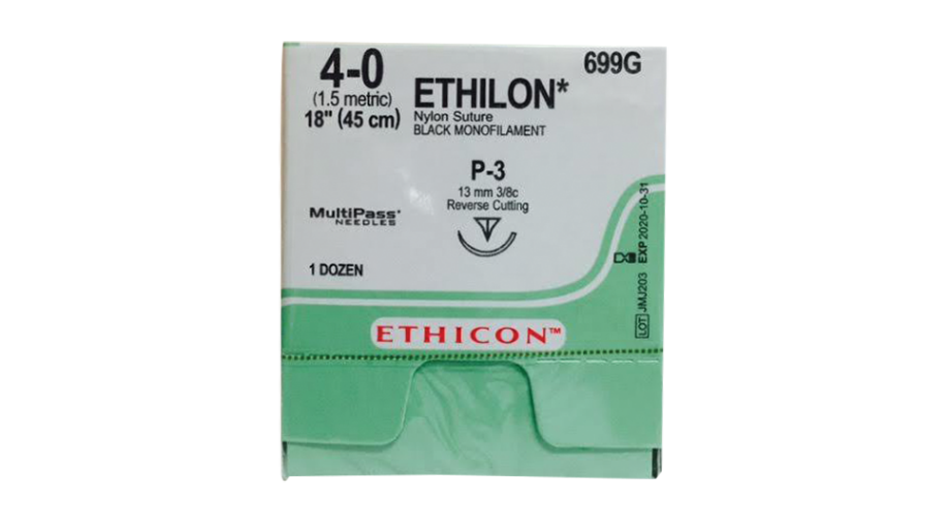

MERSILENE Polyester Fiber Suture
MERSILENE Suture is a nonabsorbable, braided, sterile surgical suture composed of Poly (ethylene terephthalate). It is prepared from fibers of high molecular weight, long-chain, linear polyesters having recurrent aromatic rings as an integral component.
MERSILENE Sutures are indicated for use in general soft tissue approximation and/or ligation, including use in cardiovascular, ophthalmic and neurological procedures and also for the fixation of soft tissue to bone tissue.

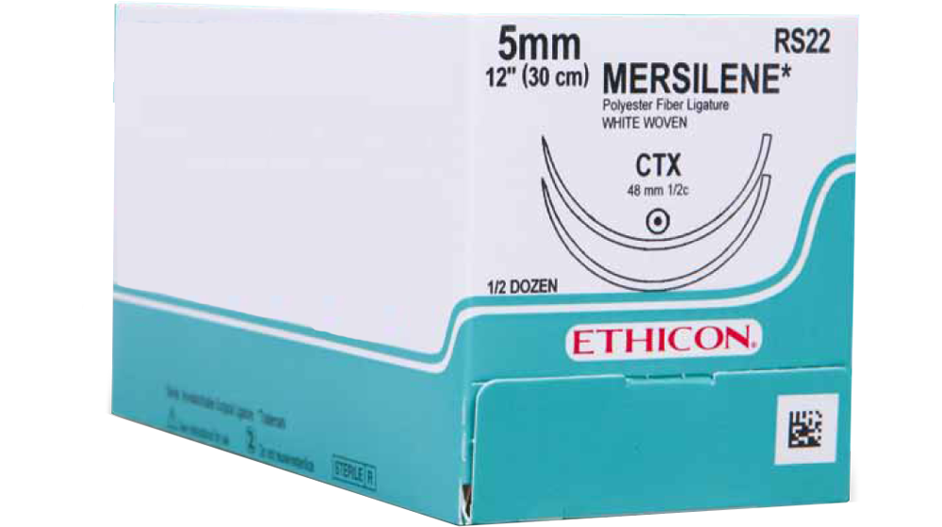

PROLENE Polypropylene Suture
PROLENE Sutures (dyed or undyed) are non-absorbable, sterile surgical suture composed of an isotactic crystalline steroisomer of polypropylene, a synthetic linear polyolefin. The dyed suture is pigmented blue to enhance visibility.
PROLENE Sutures are indicated for use in general soft tissue approximating and/or ligation, including use in cardiovascular, ophthalmic and neurosurgical procedures.

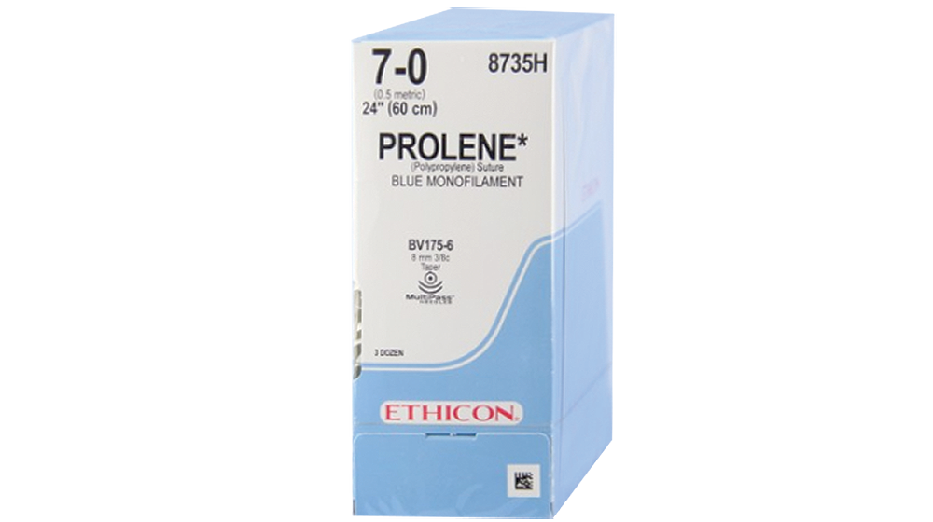

Compiled by Leanne Stevens June 2018
Last Updated June 2018

